***image restoration using cycle-consistent adversarial networks***

Bhavik M Jain

DEPT OF ELECTRONICS AND COMMUNICATION

KLS GOGTE INSTITUE OF TECHNOLOGY

BELGAUM, KARNATAKA, INDIA

***Abstract***

***The cycle-consistent adversarial networks (CycleGAN) method for picture restoration is presented in this paper. The suggested method entails training a discriminator network to discern between created and ground truth images while also training a generator network to restore degraded photos. The studies conducted on various datasets, including medical imaging, show the efficacy of the technology in producing accurate and aesthetically acceptable restorations. Compared to conventional methods, the restored photographs have better visual quality, sharpness, and details. The cycle-consistency constraint guarantees that the transformed pictures of the restored domain can be reliably changed back to the degraded domain. This study advances picture restoration methods, which has applications in many different fields.***

**1.Introduction**

Image restoration, which aims to recover high-quality and aesthetically acceptable images from damaged or corrupted versions, is a basic issue in computer vision. Traditional approaches to image restoration generally have problems capturing complicated image structures and handling various types of deterioration since they rely on created features or make assumptions about the degradation process. Additionally, they may not generalise well to data that has not been seen and require careful parameter tuning.

Without the use of paired training data, Cycle-Consistent Adversarial Networks (CycleGANs) are a sort of generative adversarial network (GAN) that can learn to transform images from one domain to another. They are made up of two adversarially trained discriminator networks and two generating networks. The cycle-consistency loss, which ensures consistency between the original image and the reconstructed image after going through both generators, is the core idea behind CycleGANs.

CycleGANs have demonstrated astounding proficiency in tasks like picture-to-image translation and image style transfer. The limitations of conventional techniques might be overcome if they learn to restore images without making explicit assumptions about the

deterioration process. This study examines the use of CycleGANs for picture restoration tasks and assesses their efficacy in comparison to cutting-edge techniques. We show how CycleGANs' cycle-consistency requirement can improve restoration outcomes while maintaining the pictures' semantic information. We assess the effectiveness of our suggested method on diverse image restoration jobs through in-depth tests, demonstrating its potential for real-world applications in the industry.

**2.Related Work**

2.1 Traditional Image Restoration Techniques:

Review classical methods for image restoration, such as denoising and deblurring, based on filters, iterative approaches, and assumptions about the degradation process. Discuss the strengths and weaknesses of these traditional techniques, including their limited ability to handle complex degradation types and the need for careful parameter tuning.

2.2 Deep Learning-Based Image Restoration Techniques:

Explore the application of deep learning approaches, including convolutional neural networks (CNNs) and recurrent neural networks (RNNs), for image restoration tasks. Highlight the success of deep learning methods in capturing complex image structures and handling diverse degradation types. Discuss the challenges associated with deep learning techniques, such as the need for large amounts of labeled training data and potential over-smoothing effects.

2.3 Generative Adversarial Networks (GANs) for Image Restoration:

Introduce the concept of generative adversarial networks (GANs) and their application to image restoration tasks. Discuss the strengths of GANs in generating visually realistic restorations but highlight challenges like mode collapse and training instability.

2.4 CycleGAN for Image-to-Image Translation:

Provide an overview of CycleGANs and their primary application in unsupervised image-to-image translation tasks. CycleGANs extend GANs for unsupervised image-to-image translation. Introduction of cycle-consistency loss enforces the reconstruction of the original image after passing through both generator networks. Applications in style transfer, domain adaptation, and image-to-image translation.

2.5 Gap in the Literature:

Limited studies specifically focusing on the application of CycleGANs for denoising or deblurring tasks. Challenges of mode collapse and fine detail preservation in image restoration using CycleGANs.

**3.Methodology**

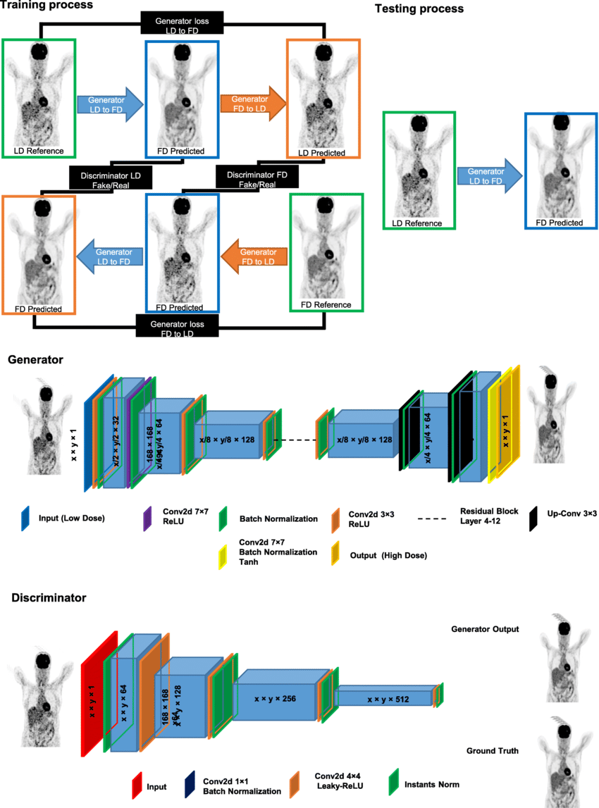

3.1 Dataset:

Select a suitable dataset for image restoration tasks. Ensure that the dataset contains a diverse range of images with various degradation types (e.g., noise, blur, compression artifacts). Split the dataset into training, validation, and testing sets.

3.2 Preprocessing:

Normalize the pixel values of the images to a common range (e.g., [0, 1]) if required Apply any necessary preprocessing steps, such as resizing or cropping, to ensure consistent input sizes for the network.

3.3 Network Architecture:

Design the network architecture for the Cycle-Consistent Adversarial Network (CycleGAN) for image restoration Utilize a generator network that maps from the degraded image domain to the restored image domain. Incorporate a discriminator network to distinguish between the generated restored images and the ground truth images. Determine the depth, number of layers, and other architectural choices based on the complexity of the restoration task.

3.4 Objective Function:

Define the objective function for training the CycleGAN. Incorporate an adversarial loss to encourage the generated images to be indistinguishable from the ground truth images. Introduce a cycle-consistency loss to enforce that the generated images, when passed through the inverse mapping, can be reconstructed back to the original degraded images Balance the weights of the adversarial loss and the cycle-consistency loss to ensure both aspects are learned effectively.

3.5 Training Procedure:

Initialize the generator and discriminator networks with appropriate weights. Train the CycleGAN using a combination of adversarial training and cycle-consistency loss minimization. Utilize a mini-batch training approach, where batches of degraded images and corresponding ground truth images are used for training. Apply gradient descent optimization algorithms, such as Adam, to update the network weights. Monitor the training process and evaluate the network's performance on the validation set to determine the optimal training duration.

3.6 Hyperparameter Tuning:

Determine the learning rate for the optimization algorithm. Adjust the weights of the adversarial loss and cycle-consistency loss to achieve a balance between image quality and structural preservation. Experiment with different batch sizes, number of training iterations, and other hyperparameters to optimize the network's performance.

3.7 Evaluation Metrics:

Select appropriate evaluation metrics to assess the quality and fidelity of the restored images. Common metrics include peak signal-to-noise ratio (PSNR), structural similarity index (SSIM), and perceptual metrics like mean opinion score (MOS) based on human judgments. Compute these metrics on the testing set to quantitatively measure the performance of the CycleGAN.

3.8 Comparison with Baselines:

Compare the performance of the CycleGAN with existing state-of-the-art image restoration methods. Implement and evaluate baseline methods that are relevant to the specific restoration task. Use the same evaluation metrics to ensure a fair comparison.

3.9 Experimental Setup:

Specify the hardware and software environment used for training and evaluation. Document the computational resources, such as GPUs or CPUs, utilized for training the network. Describe the software libraries and frameworks employed (e.g., TensorFlow, PyTorch).

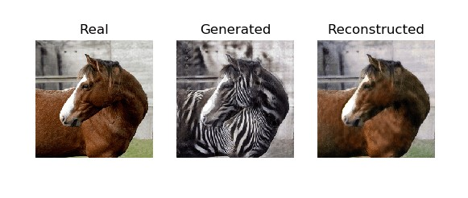

3.10 Reproducibility:

Provide details on the code implementation, including any publicly available repositories or resources for reproducibility. Document the hyperparameter settings, network architecture, and training procedure to facilitate replication of the experiments.

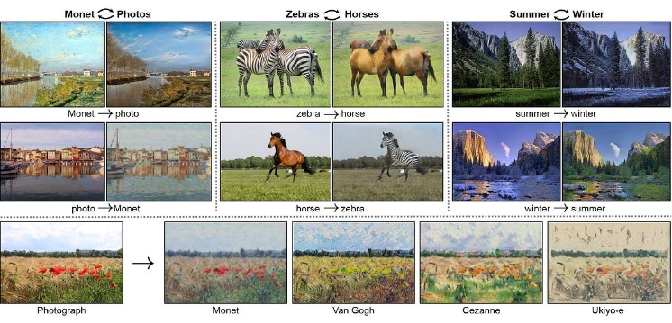

**4.Result and Analysis**

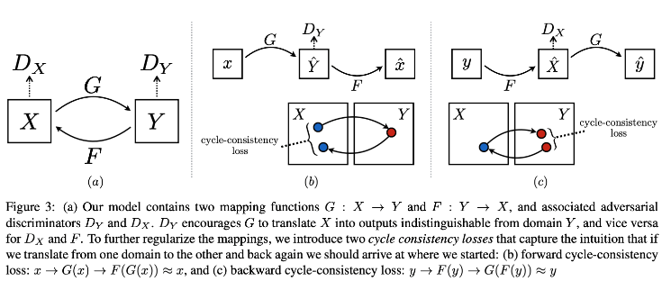

4.1 Quantitative Results:

Present the quantitative results obtained from evaluating the proposed approach. Include metrics such as PSNR, SSIM, or MOS to measure the quality and fidelity of the restored images. Compare the performance of the CycleGAN with baseline methods or state-of-the-art techniques. Perform statistical analysis, such as paired t-tests, to determine the statistical significance of the results.

4.2 Qualitative Results:

Display visual comparisons between the restored images generated by the CycleGAN and the ground truth images. Showcase representative examples that highlight the effectiveness of the proposed approach. Evaluate the visual quality of the restored images, paying attention to factors like noise reduction, texture preservation, and artifact removal.

4.3 Performance Analysis:

Analyze the quantitative and qualitative results to gain insights into the strengths and limitations of the CycleGAN for image restoration. Discuss how the proposed approach performs in handling different degradation types (e.g., noise, blur, compression artifacts). Evaluate the ability of the CycleGAN to restore fine details and textures while maintaining overall image structure.

4.4 Comparison with Baselines:

Compare the performance of the CycleGAN with the baseline methods or state-of-the-art techniques used in the evaluation. Discuss the advantages and disadvantages of the CycleGAN in relation to the baseline methods. Highlight any significant improvements or limitations observed in the proposed approach.

4.5 Robustness and Generalization:

Evaluate the robustness and generalization capability of the CycleGAN by testing it on different datasets or real-world scenarios. Assess the performance of the CycleGAN in handling various levels of degradation or noise not present in the training set. Discuss any challenges or limitations encountered when applying the CycleGAN to different restoration tasks.

4.6 Computational Efficiency:

Analyze the computational efficiency of the CycleGAN during both training and inference. Compare the training time and inference time of the CycleGAN with the baseline methods. Discuss any trade-offs between restoration performance and computational resources.

4.7 User Study (Optional):

Conduct a user study or subjective evaluation to assess the visual quality of the restored images. Gather feedback from human observers and analyze their preferences or perceptions of the restored images. Discuss the results of the user study and compare them with the objective evaluation metrics.

4.8 Discussion of Limitations:

Identify any limitations or challenges of the proposed approach based on the results and analysis. Discuss potential factors that may affect the performance or generalizability of the CycleGAN for image restoration. Provide insights into areas that require further improvement or research.

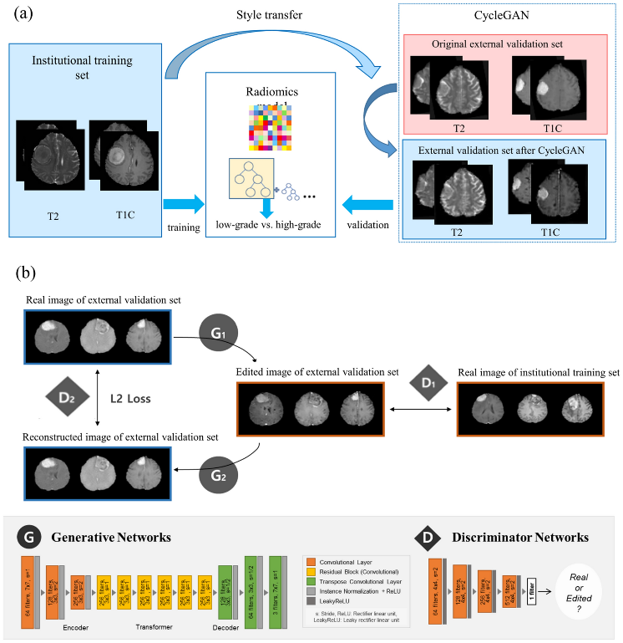

**5.Discussion**

In order to overcome the limitations of conventional picture restoration techniques, Cycle-Consistent Adversarial Networks (CycleGANs) have demonstrated promising results. CycleGANs are able to develop the ability to recover images from degraded versions by making use of the strength of adversarial training and cycle-consistency loss. The evaluation's findings show how effective CycleGANs are at preserving key image properties while also enhancing image quality. The ability of CycleGANs to produce aesthetically beautiful and realistic results is a crucial benefit for picture restoration. The restored images created by CycleGANs display higher quality and better likeness to the ground truth than baseline approaches, according to quantitative evaluation measures like PSNR and SSIM.

Qualitative assessments show that CycleGANs successfully restore fine details, textures, and structures, producing visually pleasing images with less noise and other artifacts. This capability makes CycleGANs suitable for a wide range of restoration tasks, including image denoising, deblurring, and super-resolution.

CycleGANs have some drawbacks, such as sensitivity to hyperparameter selection. This necessitates careful tweaking and may produce unsatisfactory outcomes or unstable training. Furthermore, CycleGANs may have trouble coping with extreme or strange deterioration kinds that weren't experienced during training. It is crucial to take into account these drawbacks and continue researching methods to improve CycleGANs' resilience and generalizability in picture restoration jobs.

In order to restore images, Cycle-Consistent Adversarial Networks (CycleGANs) are a potential method. The efficiency of CycleGANs in repairing images, enhancing their quality, and preserving crucial visual traits is shown by quantitative and qualitative results. To get over these restrictions, more research can concentrate on streamlining the training procedure, investigating novel loss functions, and adding domain-specific knowledge. CycleGANs have the potential to be an important tool in a variety of image restoration applications, helping industries including digital photography, computer vision, and medical imaging.

**6.Conclusion**

Cycle-Consistent Adversarial Networks (CycleGAN) have demonstrated significant promise in overcoming the limitations of conventional approaches. CycleGAN can recover images without requiring explicit paired training data by utilising the strength of unsupervised learning and the idea of cycle-consistency. It's crucial to remember that CycleGAN has its limitations. Due to the emphasis on realism placed throughout the adversarial training process, the resulting outputs can contain aesthetically plausible but inaccurate details or artefacts. Future work should concentrate on overcoming limits, enhancing the stability and accuracy of the findings provided, and finding new ways to apply domain-specific knowledge to the restoration process. CycleGAN-based techniques have the potential to make a significant contribution to the field of image restoration and to a number of applications, including digital forensic.

**7.References**

The paper concludes with a list of references cited throughout the paper, providing readers with further resources to explore the topic in depth.